8086 microprocessor

Intel 8086

* Intel 8086 microprocessor is the enhanced version of Intel 8085 microprocessor. It was designed by Intel in 1976.
* The 8086 microprocessor is a16-bit, N-channel, HMOS microprocessor. Where the HMOS is used for "**High-speed Metal Oxide Semiconductor**".
* Intel 8086 is built on a single semiconductor chip and packaged in a 40-pin IC package. The type of package is DIP (Dual Inline Package).
* Intel 8086 uses 20 address lines and 16 data- lines. It can directly address up to 220 = 1 Mbyte of memory.
* It consists of a powerful instruction set, which provides operation like division and multiplication very quickly.
* 8086 is designed to operate in two modes, i.e., Minimum and Maximum mode.

Difference between 8085 and 8086 Microprocessor

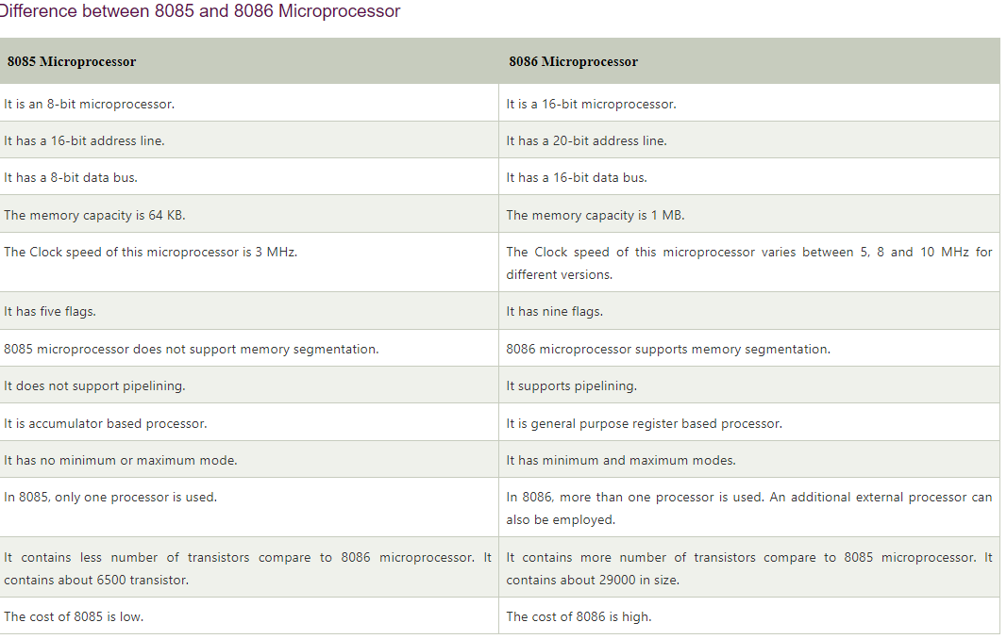

8086 pins configuration

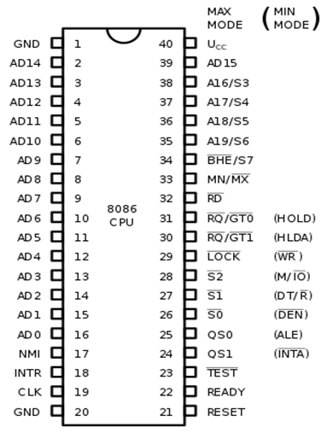

The description of the pins of 8086 is as follows:

**AD0-AD15 (Address Data Bus):** Bidirectional address/data lines. These are low order address bus. They are multiplexed with data.

When these lines are used to transmit memory address, the symbol A is used instead of AD, for example, A0- A15.

**A16 - A19 (Output):** High order address lines. These are multiplexed with status signals.

**A16/S3, A17/S4:** A16 and A17 are multiplexed with segment identifier signals S3 and S4.

**A18/S5:** A18 is multiplexed with interrupt status S5.

**A19/S6:** A19 is multiplexed with status signal S6.

**BHE/S7 (Output):** Bus High Enable/Status. During T1, it is low. It enables the data onto the most significant half of data bus, D8-D15. 8-bit device connected to upper half of the data bus use BHE signal. It is multiplexed with status signal S7. S7 signal is available during T3 and T4.

**RD (Read):** For read operation. It is an output signal. It is active when LOW.

**Ready (Input):** The addressed memory or I/O sends acknowledgment through this pin. When HIGH, it denotes that the peripheral is ready to transfer data.

**RESET (Input):** System reset. The signal is active HIGH.

**CLK (input):** Clock 5, 8 or 10 MHz.

**INTR:** Interrupt Request.

**NMI (Input):** Non-maskable interrupt request.

**TEST (Input):** Wait for test control. When LOW the microprocessor continues execution otherwise waits.

**VCC:** Power supply +5V dc.

**GND:** Ground.

Operating Modes of 8086

There are two operating modes of operation for Intel 8086, namely the **minimum mode** and the **maximum mode**.

When only one 8086 CPU is to be used in a microprocessor system, the 8086 is used in the **Minimum mode** of operation.

In a multiprocessor system 8086 operates in the **Maximum mode**.

Pin Description for Minimum Mode

In this minimum mode of operation, the pin MN/MX is connected to 5V D.C. supply i.e. MN/MX = VCC.

**The description about the pins from 24 to 31 for the minimum mode is as follows:**

**INTA (Output):** Pin number 24 interrupts acknowledgement. On receiving interrupt signal, the processor issues an interrupt acknowledgment signal. It is active LOW.

**ALE (Output):** Pin no. 25. Address latch enable. It goes HIGH during T1. The microprocessor 8086 sends this signal to latch the address into the Intel 8282/8283 latch.

**DEN (Output):** Pin no. 26. Data Enable. When Intel 8287/8286 octal bus transceiver is used this signal. It is active LOW.

**DT/R (output):** Pin No. 27 data Transmit/Receives. When Intel 8287/8286 octal bus transceiver is used this signal controls the direction of data flow through the transceiver. When it is HIGH, data is sent out. When it is LOW, data is received.

**M/IO (Output):** Pin no. 28, Memory or I/O access. When this signal is HIGH, the CPU wants to access memory. When this signal is LOW, the CPU wants to access I/O device.

**WR (Output):** Pin no. 29, Write. When this signal is LOW, the CPU performs memory or I/O write operation.

**HLDA (Output):** Pin no. 30, Hold Acknowledgment. It is sent by the processor when it receives HOLD signal. It is active HIGH signal. When HOLD is removed HLDA goes LOW.

**HOLD (Input):** Pin no. 31, Hold. When another device in microcomputer system wants to use the address and data bus, it sends HOLD request to CPU through this pin. It is an active HIGH signal.

Pin Description for Maximum Mode

In the maximum mode of operation, the pin MN/¯MX is made LOW. It is grounded. The description about the pins from 24 to 31 is as follows:

**QS1, QS0 (Output):** Pin numbers 24, 25, Instruction Queue Status. Logics are given below:

|  |  |  |
| --- | --- | --- |
| **QS1** | **QS0** | **Operation** |
| 0 | 0 | No operation |
| 0 | 1 | 1st byte of opcode from queue. |
| 1 | 0 | Empty the queue |
| 1 | 1 | Subsequent byte from queue |

**S0, S1, S2 (Output):** Pin numbers 26, 27, 28 Status Signals. These signals are connected to the bus controller of Intel 8288. This bus controller generates memory and I/O access control signals. Logics for status signal are given below:

|  |  |  |  |
| --- | --- | --- | --- |
| **S2** | **S1** | **S0** | **Operation** |
| 0 | 0 | 0 | Interrupt acknowledgement |
| 0 | 0 | 1 | Read data from I/O port |
| 0 | 1 | 0 | Write data from I/O port |
| 0 | 1 | 1 | Halt |
| 1 | 0 | 0 | Opcode fetch |
| 1 | 0 | 1 | Memory read |
| 1 | 1 | 0 | Memory write |
| 1 | 1 | 1 | Passive state |

**LOCK (Output):** Pin no. 29. It is an active LOW signal. When this signal is LOW, all interrupts are masked and no HOLD request is granted. In a multiprocessor system all other processors are informed through this signal that they should not ask the CPU for relinquishing the bus control.

RG/GT1, RQ/GT0 (Bidirectional): Pin numbers 30, 31, Local Bus Priority Control. Other processors ask the CPU by these lines to release the local bus.

In the maximum mode of operation signals WR, ALE, DEN, DT/R etc. are not available directly from the processor. These signals are available from the controller 8288.

Functional units of 8086

8086 contains two independent functional units: **a Bus Interface Unit (BIU)** and an **Execution Unit (EU)**.

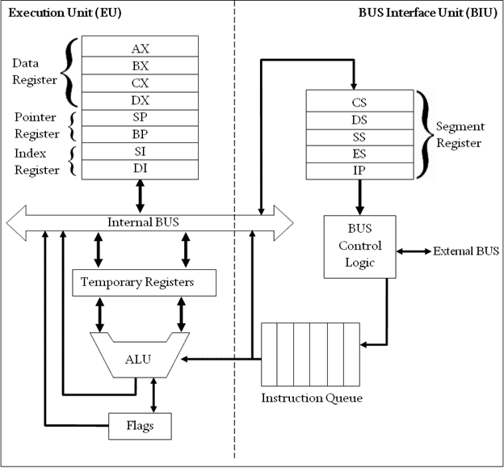

**Fig: Block Diagram of Intel 8086 Microprocessor (8086 Architecture)**

Bus Interface Unit (BIU)

The segment registers, instruction pointer and 6-byte instruction queue are associated with the bus interface unit (BIU).

The BIU:

* Handles transfer of data and addresses,
* Fetches instruction codes, stores fetched instruction codes in first-in-first-out register set called a **queue**,
* Reads data from memory and I/O devices,
* Writes data to memory and I/O devices,
* It relocates addresses of operands since it gets un-relocated operand addresses from EU. The EU tells the BIU from where to fetch instructions or where to read data.

It has the following functional parts:

* **Instruction Queue:** When EU executes instructions, the BIU gets 6-bytes of the next instruction and stores them in the instruction queue and this process is known as instruction pre fetch. This process increases the speed of the processor.
* **Segment Registers:** A segment register contains the addresses of instructions and data in memory which are used by the processor to access memory locations. It points to the starting address of a memory segment currently being used.  
  There are 4 segment registers in 8086 as given below:
  + **Code Segment Register (CS):** Code segment of the memory holds instruction codes of a program.
  + **Data Segment Register (DS):** The data, variables and constants given in the program are held in the data segment of the memory.
  + **Stack Segment Register (SS):** Stack segment holds addresses and data of subroutines. It also holds the contents of registers and memory locations given in PUSH instruction.
  + **Extra Segment Register (ES):** Extra segment holds the destination addresses of some data of certain string instructions.
* **Instruction Pointer (IP):** The instruction pointer in the 8086 microprocessor acts as a program counter. It indicates to the address of the next instruction to be executed.

Execution Unit (EU)

* The **EU** receives opcode of an instruction from the queue, decodes it and then executes it. While Execution, unit decodes or executes an instruction, then the BIU fetches instruction codes from the memory and stores them in the queue.
* The BIU and EU operate in parallel independently. This makes processing faster.
* General purpose registers, stack pointer, base pointer and index registers, ALU, flag registers (FLAGS), instruction decoder and timing and control unit constitute execution unit (EU). Let's discuss them:
* **General Purpose Registers:** There are four 16-bit general purpose registers: AX (Accumulator Register), BX (Base Register), CX (Counter) and DX. Each of these 16-bit registers are further subdivided into 8-bit registers as shown below:

|  |  |  |
| --- | --- | --- |
| **16-bit registers** | **8-bit high-order registers** | **8-bit low-order registers** |
| AX | AH | AL |
| BX | BH | BL |
| CX | CH | CL |
| DX | DH | DL |

* **Index Register:** The following four registers are in the group of pointer and index registers:
  + Stack Pointer (SP)
  + Base Pointer (BP)
  + Source Index (SI)
  + Destination Index (DI)
* **ALU:** It handles all arithmetic and logical operations. Such as addition, subtraction, multiplication, division, AND, OR, NOT operations.
* **Flag Register:** It is a 16?bit register which exactly behaves like a flip-flop, means it changes states according to the result stored in the accumulator. It has 9 flags and they are divided into 2 groups i.e. conditional and control flags.
  + **Conditional Flags:** This flag represents the result of the last arithmetic or logical instruction executed. Conditional flags are:
    - Carry Flag
    - Auxiliary Flag
    - Parity Flag
    - Zero Flag
    - Sign Flag
    - Overflow Flag
  + **Control Flags:** It controls the operations of the execution unit. Control flags are:
    - Trap Flag
    - Interrupt Flag
    - Direction Flag

Interrupts

**Interrupt** is a process of creating a temporary halt during program execution and allows peripheral devices to access the microprocessor.

Microprocessor responds to these interrupts with an **interrupt service routine (ISR)**, which is a short program or subroutine to instruct the microprocessor on how to handle the interrupt.

**There are different types of interrupt in 8086:**

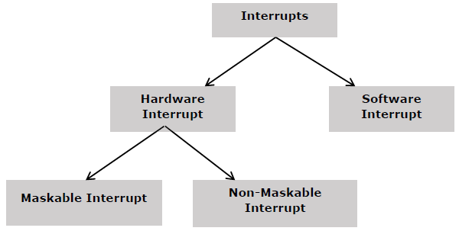

Hardware Interrupts

**Hardware interrupts** are that type of interrupt which are caused by any peripheral device by sending a signal through a specified pin to the microprocessor.

**The Intel 8086 has two hardware interrupt pins:**

* NMI (Non-Maskbale Interrupt)
* INTR (Interrupt Request) Maskable Interrupt.

**NMI:** NMI is a single Non-Maskable Interrupt having higher priority than the maskable interrupt.

* It cannot be disabled (masked) by user using software.
* It is used by the processor to handle emergency conditions.  
  **For example:** It can be used to save program and data in case of power failure. An external electronic circuitry is used to detect power failure, and to send an interrupt signal to 8086 through NMI line.

**INTR:** The INTR is a maskable interrupt. It can be enabled/disabled using interrupt flag (IF). After receiving INTR from external device, the 8086 acknowledges through INTA signal.

It executes two consecutive interrupt acknowledge bus cycles.

Software Interrupt

A microprocessor can also be interrupted by internal abnormal conditions such as overflow; division by zero; etc. A programmer can also interrupt microprocessor by inserting INT instruction at the desired point in the program while debugging a program. Such an interrupt is called a software interrupt.

The interrupt caused by an internal abnormal conditions also came under the heading of software interrupt.

**Example of software interrupts are:**

* TYPE 0 (division by zero)
* TYPE 1 (single step execution for debugging a program)
* TYPE 2 represents NMI (power failure condition)
* TYPE 3 (break point interrupt)
* TYPE 4 (overflow interrupt)

**Interrupt pointer table for 8086**

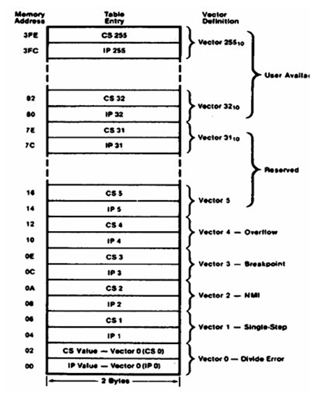

**Fig: Interrupt pointer table for 8086**

The 8086 can handle up to 256, hardware and software interrupts.

1KB memory acts as a table to contain interrupt vectors (or interrupt pointers), and it is called interrupt vector table or interrupt pointer table. The 256 interrupt pointers have been numbered from 0 to 255 (FF hex). The number assigned to an interrupt pointer is known as type of that interrupt. For example, Type 0, Type 1, Type 2,...........Type 255 interrupt.

Addressing modes of 8086

The way for which an operand is specified for an instruction in the accumulator, in a general purpose register or in memory location, is called **addressing mode**.

The 8086 microprocessors have 8 addressing modes. Two addressing modes have been provided for instructions which operate on register or immediate data.

**These two addressing modes are:**

**Register Addressing:** In register addressing, the operand is placed in one of the 16-bit or 8-bit general purpose registers.

**Example**

* MOV AX, CX
* ADD AL, BL
* ADD CX, DX

**Immediate Addressing:** In immediate addressing, the operand is specified in the instruction itself.

**Example**

* MOV AL, 35H
* MOV BX, 0301H
* MOV [0401], 3598H
* ADD AX, 4836H

The remaining 6 addressing modes specify the location of an operand which is placed in a memory.

**These 6 addressing modes are:**

**Direct Addressing:** In direct addressing mode, the operand?s offset is given in the instruction as an 8-bit or 16-bit displacement element.

**Example**

* ADD AL, [0301]

The instruction adds the content of the offset address 0301 to AL. the operand is placed at the given offset (0301) within the data segment DS.

**Register Indirect Addressing:** The operand's offset is placed in any one of the registers BX, BP, SI or DI as specified in the instruction.

**Example**

* MOV AX, [BX]

It moves the contents of memory locations addressed by the register BX to the register AX.

**Based Addressing:** The operand's offset is the sum of an 8-bit or 16-bit displacement and the contents of the base register BX or BP. BX is used as base register for data segment, and the BP is used as a base register for stack segment.

**Effective address (Offset)** = [BX + 8-bit or 16-bit displacement].

**Example**

* MOV AL, [BX+05]; an example of 8-bit displacement.
* MOV AL, [BX + 1346H]; example of 16-bit displacement.

**Indexed Addressing:** The offset of an operand is the sum of the content of an index register SI or DI and an 8-bit or 16-bit displacement.

Offset (Effective Address) = [SI or DI + 8-bit or 16-bit displacement]

**Example**

* MOV AX, [SI + 05]; 8-bit displacement.
* MOV AX, [SI + 1528H]; 16-bit displacement.

**Based Indexed Addressing:** The offset of operand is the sum of the content of a base register BX or BP and an index register SI or DI.

Effective Address (Offset) = [BX or BP] + [SI or DI]

Here, BX is used for a base register for data segment, and BP is used as a base register for stack segment.

**Example**

* ADD AX, [BX + SI]
* MOV CX, [BX + SI]

**Based Indexed with Displacement:** In this mode of addressing, the operand's offset is given by:

**Effective Address (Offset)** = [BX or BP] + [SI or DI] + 8-bit or 16-bit displacement

**Example**

* MOV AX, [BX + SI + 05]; 8-bit displacement
* MOV AX, [BX + SI + 1235H]; 16-bit displacement